**Topic Name: Spanning Tree Protocol (STP)**

**Submitted by: Submitted by:**

Md Jahidul Islam MD. Jahirul Islam

Mail: jahidislam1204.bd@gmail.com

**Spanning Tree Protocol (STP)**

**Concept of STP:** A link management protocol that prevents loops and ensures that there is only one active path between two network devices.

The main purpose of STP is to eliminate loops.

**What is loop?**

* A loop occurs when a blocking port in a redundant topology changes to a for-warding state.

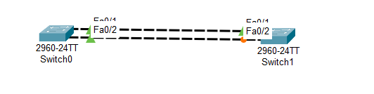

**Figure:1.1**

We know that a switch works as a broadcast.In figure 1.1 When switch0 send packet to switch1 , switch1 recieves but when switch1 braodcast this packet, the packet will go through the port1 and port2. Here create a loop. For better understand, notice the figure 1.2

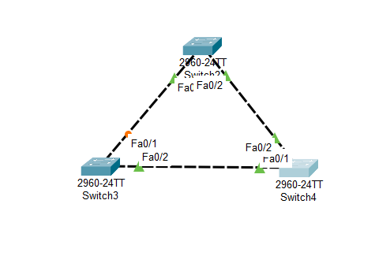

**Figure : 1.2**

* **STP**  mainly remove the loop so that there can’t be create any packet traffic. As a result user get a smoot network facility.

**Root Bridge Election :** In this state bridge is a Switch. Now we have identify the root bridge in the figure 1.2 . For identifying root bridge we have to observe 2 things.

1. Priority
2. MAC ADDRESS

**Root Bridge = Priority + Mac Address**

The rules of being a root bridge, which port has lower value of sum(Priority + Mac Address).

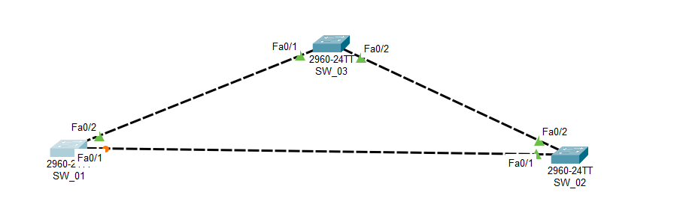

Figure: 1.3

Let’s go to identify the root bridge between 3 switches.

**SW_01:**

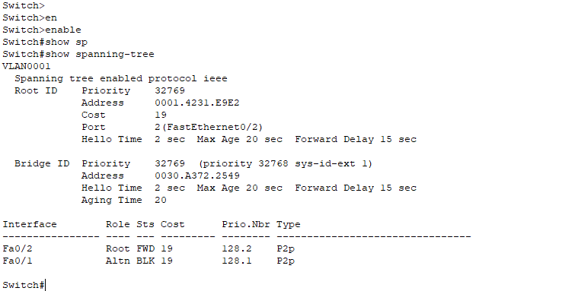

For Switch1

Priority = 32769

Mac Address = 0030.A372.2549

**SW_02:**

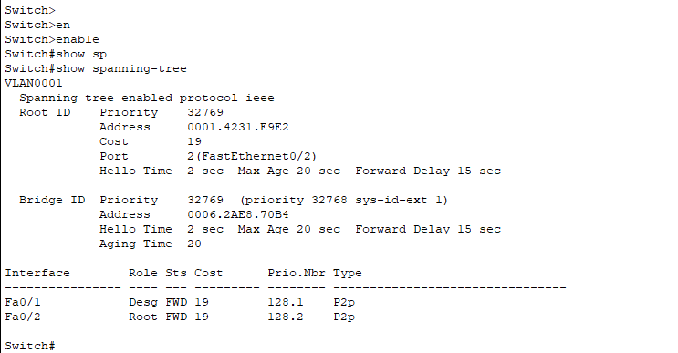

For Switch2

Priority = 32769

Mac Address = 0006.2AE8.70B4

**SW_03:**

For switch3

Priority = 32769

Mac Address = 0001.4231.E9E2

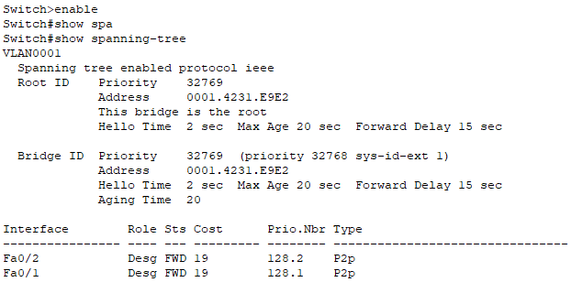

For figure 1.3

The Root bridge is SW_03

Three switches have same priority value. But the lower value of Mac address is in SW_03.

**STP Port Status:** There are 4 types of port status in STP.

* Disable state(stable) ---- >20 sec delay

A port that is shutdown

* Listening(Transitional) ---- >15 sec delay
* Not forwarding traffic but learning MAC address
* Learning(Transitional) ---- >15 sec delay

Not forwarding traffic but learning MAC address

* Forwarding/Blocking(stable)

A port that is forwarding and blocking traffic

*Root ports remain stable in forwarding state

* Non-designated ports remain stable in a Blocking state.

* Listening and Leaning are transitional states which are passed through when an interface is activated, or when a Blocking port must transition to a forwarding state due to a change in the network topology.

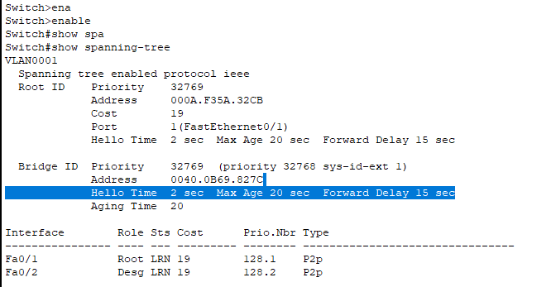

**Roles Of STP:** There are three major role of stp.

* **Designated Ports :** All the port of Root Bridge will remain in the designated role.

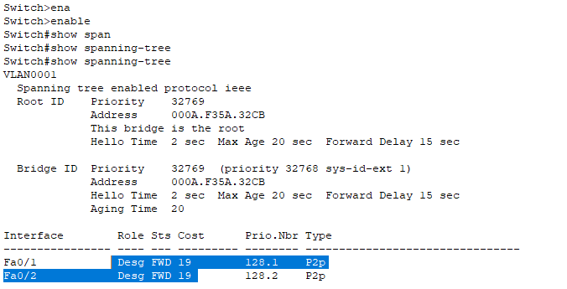

* **Root Ports :** The best port to reach the root Bridge.

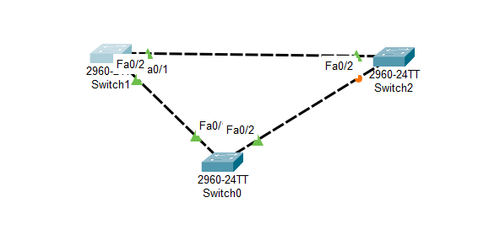

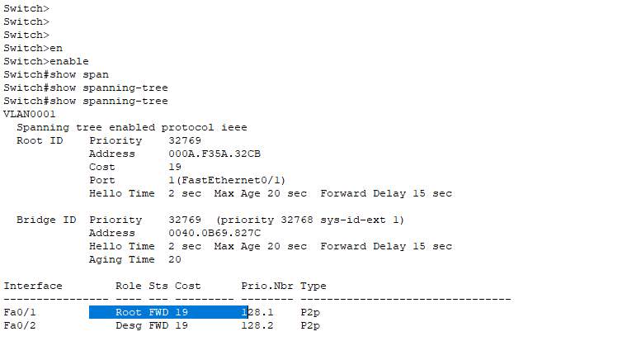

Designated and root role always go through the forwarding state

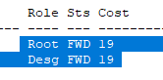

* **Non-Designated :** All other ports that are in a blocking state.

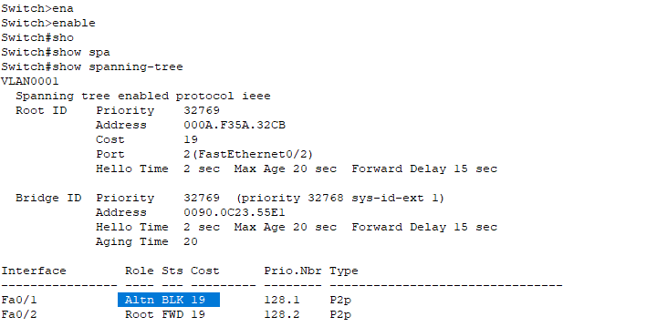

Non-Designated/Alternate role always go through the blocking state

**How to make Root state for making forwarding mode one non-root port:**

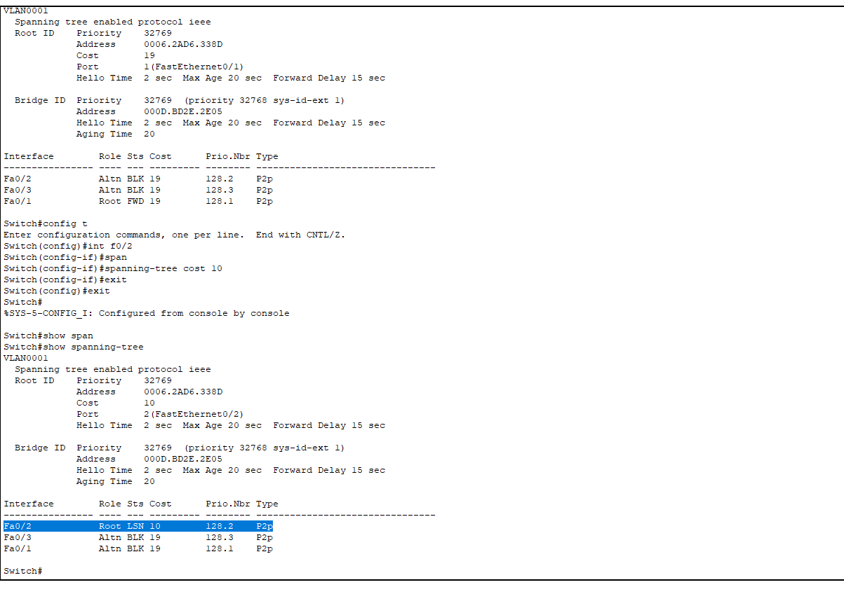

**How to make Root Bridge Manually:**

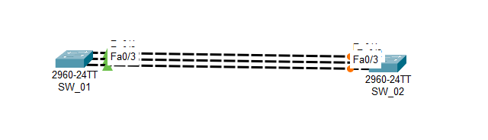

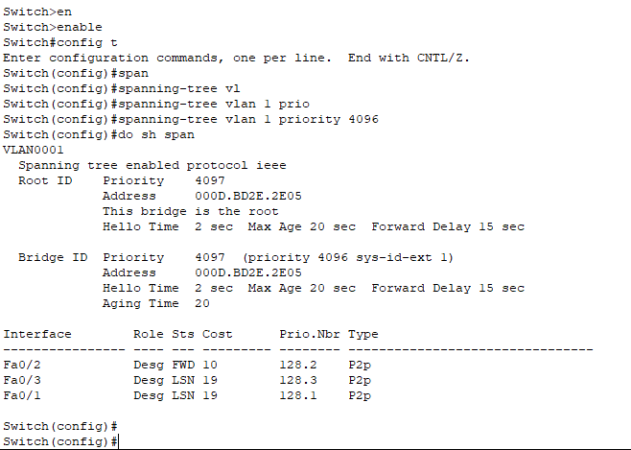

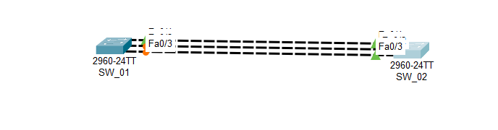

**PortFast Cmnd:** We use portfast command for reducing the delay when we connect any end-device with switch.

